CURRICULUM VITAE

PERSONAL INFORMATION

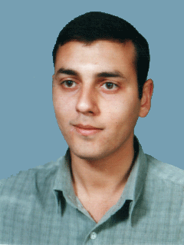

NAME: MOHAMMED A. F. AFIFI
DATE OF BIRTH: September 2,1980
PALCE OF BIRTH: Kuwait
GENDER: Male
NATIONALITY: Palestinian
MARILITY: Single
LANGUAGES: Arabic (Mother tongue), Fluent
English (Very Good)
ADDRESS: Al Rimal - Qadisyah St.
P.O.BOX: 1137 Al Rimal GAZA
Home: 970 8 2869623
Mobile: 970 599 341633
Office: 970 8 2829173
E-mail: afifi_m80@hotmail.com

QUALIFICATIONS
- B.Sc. in Technology & Applied Science
(Computer Information Systems) May 2002
Al Quds Open University –Gaza

Certification
- MCP, MCSA, MCSE, MCAD, Oracle

Experience In Brief
Since 2002 I'm working for Ministry of Health in Computer filed, through this time I'm Playing many roles as programmer, team leader for developer team and now as Web Master & Developer for MOH web site.

As IT Professional I'm establishing Afifi Information Technology Co. – AfifiTECH specialized in Information Technology and training, also I'm sharing and executing "E-library, Updating National Palestinian Health Data Dictionary" in MOH, through my experience of my job and Courses I'm working as a trainer with many Association and universities in Gaza Strip for ICDL Certification, Network + and Computer Maintenance.

Mohammed Afifi

